

**MATHEMATICS**

**Specialist Units 3 & 4**

**Test 5 – Applications of Differentiation and Differential Equations**

**Chapters 12 and 16**

**Semester 2 2017**

# 

**Section One – Calculator Free**

Time allowed for this section

Working time for this section: 15 minutes

Marks available: 17 marks

## Material required/recommended for this section

##### To be provided by the supervisor

This Question/Answer booklet

Formula sheet

##### To be provided by the candidate

Standard items: pens, pencils, pencil sharpener, eraser, correction fluid, ruler, highlighters

Special items: Nil

## Important note to candidates

No other items may be used in this section of the examination. It is **your** responsibility to ensure that you do not have any unauthorised notes or other items of a non-personal nature in the examination room. If you have any unauthorised material with you, hand it to the supervisor **before** reading any further.

1. (3 marks)  
   The equation of a curve is $y^{4}+x^{2}y^{2}=2a^{3}(x+2a)$, where *a* is a constant. Find the gradient of the curve at the point (3a, a).
2. (3 marks)  
   Find the equation relating $x$ and $y$, given the differential equation $cosy\frac{dy}{dx}=2x+1$ and $y=\frac{π}{2}$ when $x=3$.
3. (5 marks)  
   Consider the diagram provided below.  is a chord of fixed length and Q can be located anywhere on the major arc AB, meaning will be constant no matter where exactly Q is.

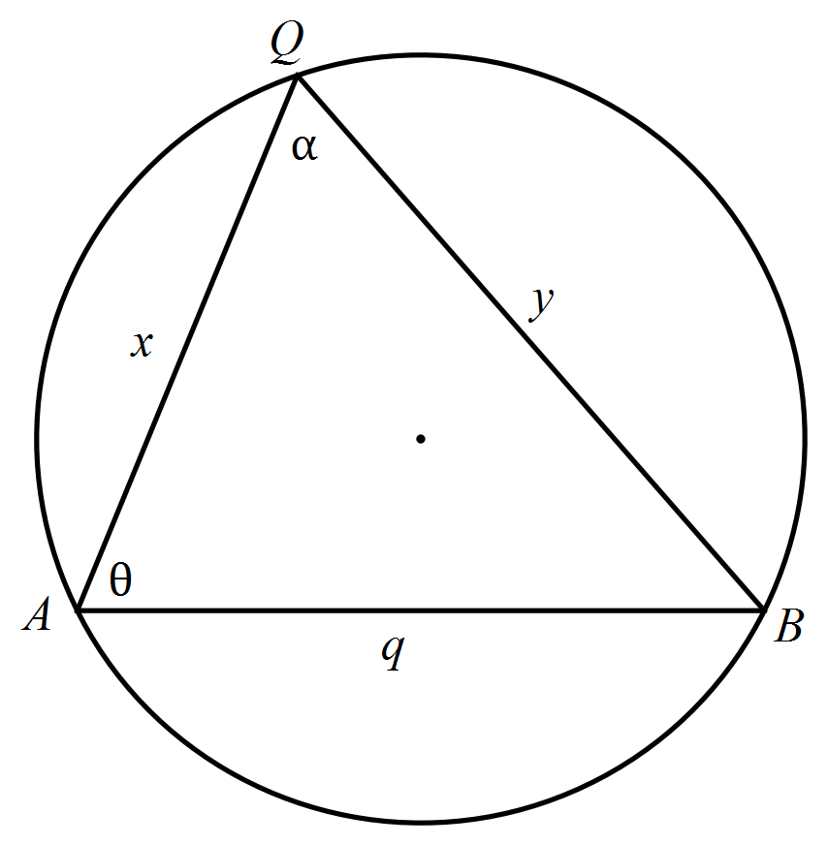

1. Write an expression for q in terms of x, y and α. [1]
2. Write an expression for $\frac{dy}{dx}$ in terms of x, y and α, remembering that q and α are constants. [2]
3. Justify that y is a stationary point where $cosα=\frac{x}{y}$ [2]
4. (6 marks)  
   The slope field for the differential equation $\frac{dy}{dx}=2(y+1)$ is shown below.

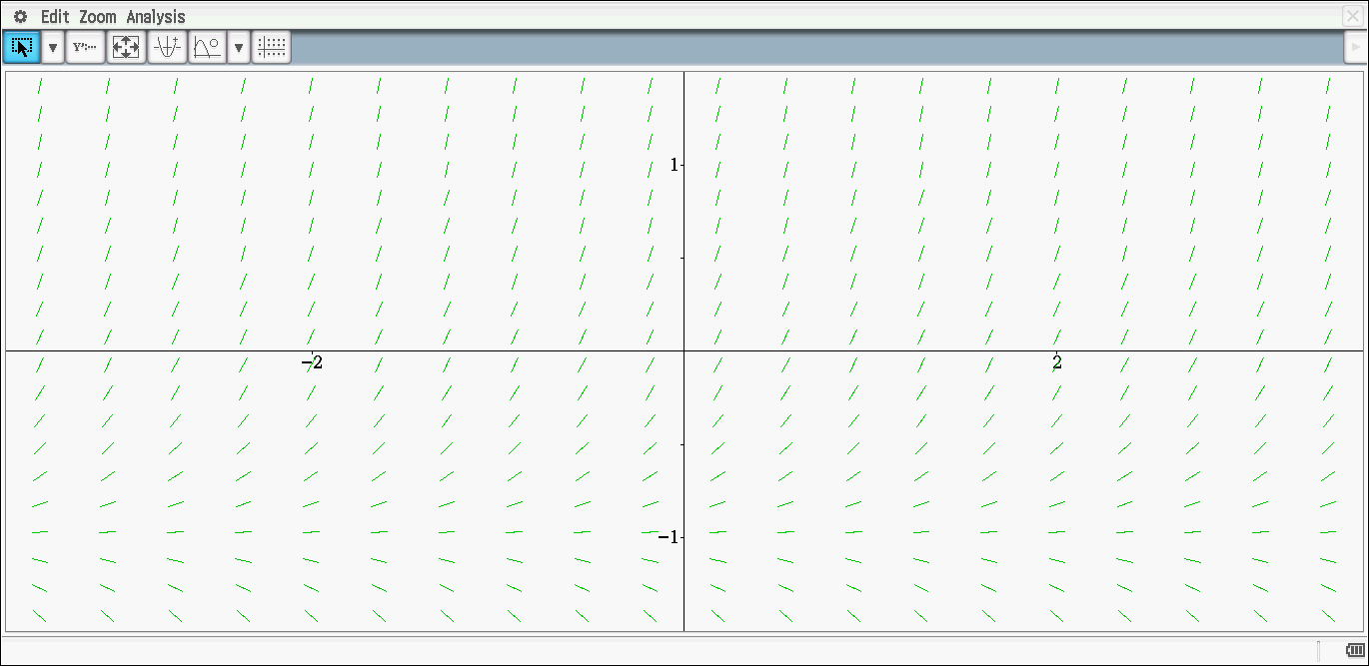

1. Sketch the solution curve which passes through (0, 1). [2]
2. Determine the equation of the solution curve drawn in part a. [4]

**End of Section One**

**This page has intentionally been left blank**

You may use this space to extend or re-attempt an answer to a question or questions and should you do so then number the question(s) attempted and cross out any previous unwanted working.